Setup Backup in Ave Point:

Backup of content

Navigate to Control Panel -> Data Management -> Device Manager
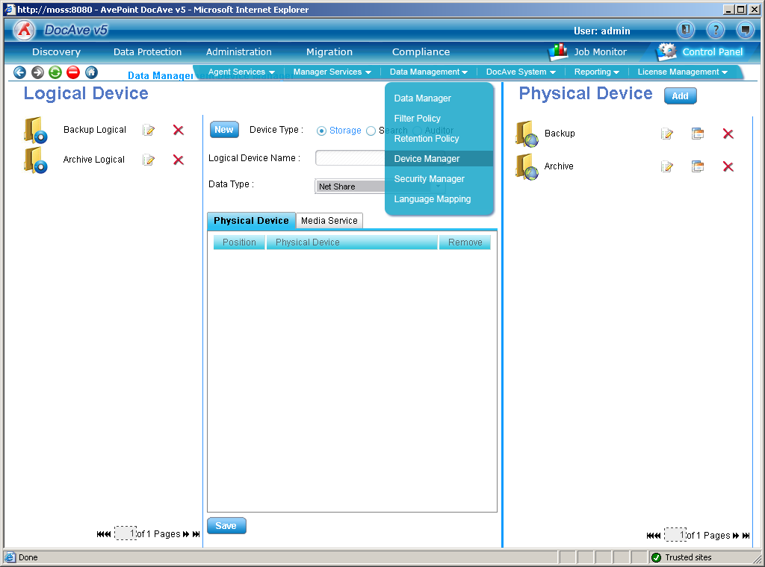

Under Physical Device Click Add and enter location of Backup Drive\Share

Click Save
Under Logical Device Enter a Name
Drag the Physical Device into the centre window

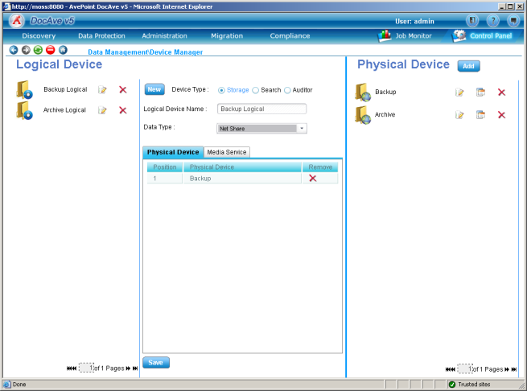
Select the Media Server Tab
And drag the media server in to the center window
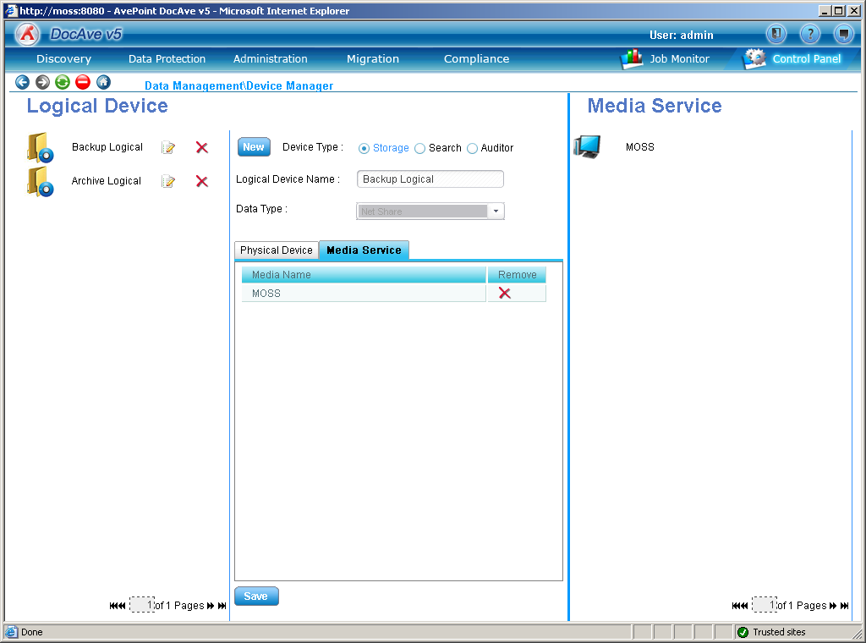
Click Save
Navigate to Data Protection -> Custom Backup Builder -> Granular Backup
Enter the Name of the Plan
Run though each central tab starting with Data Manager
Select the appropriate rules – defined under Control Panel – Data Management
Data Manger
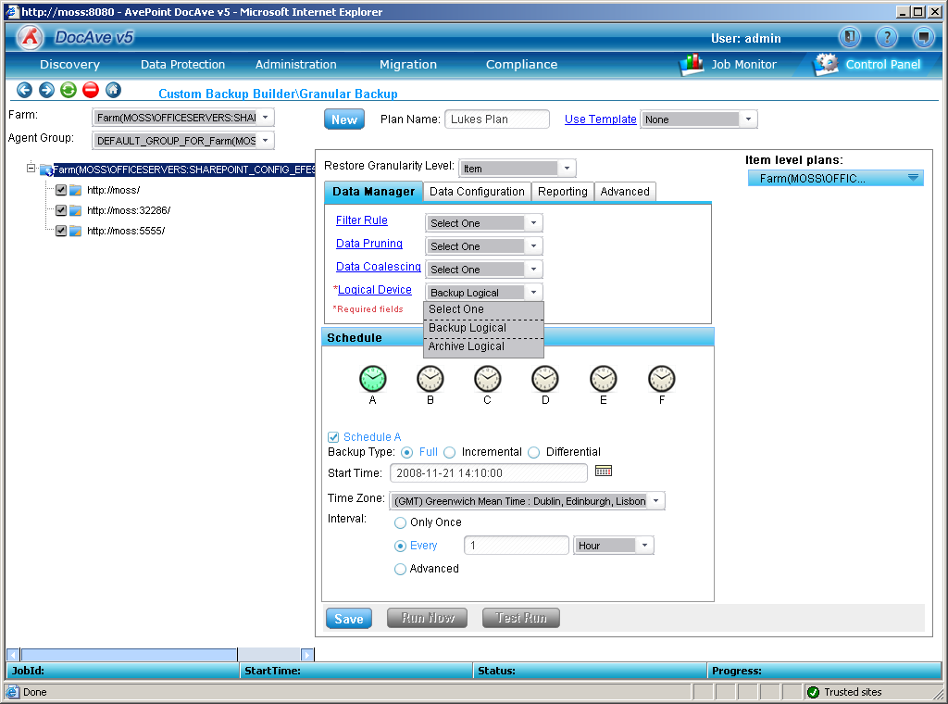
Data configuration
Reporting
Advanced

In the left hand pane select the server farm and Agent Group
Either Select all the Moss farms of select a specific Library to see what is contained in a libarary click on the info button
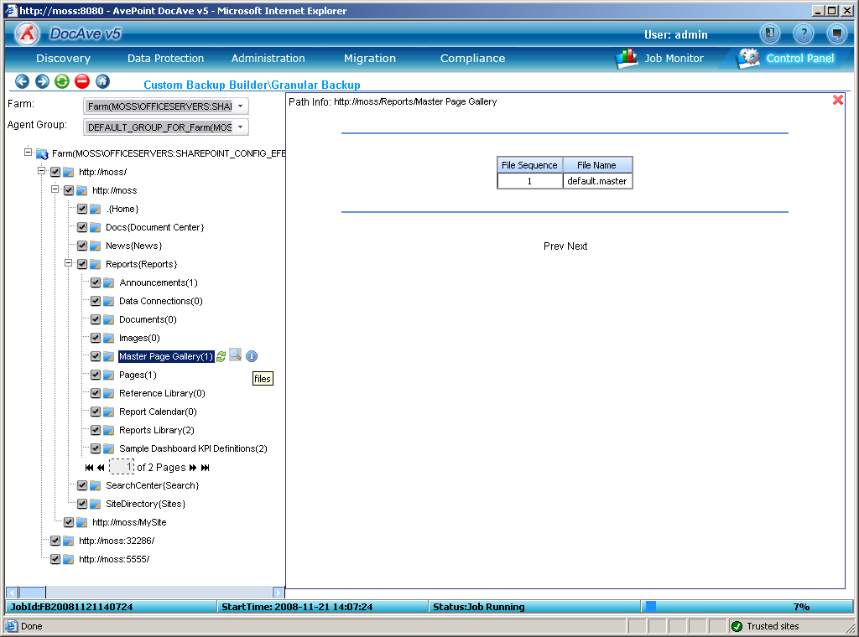
Click on the cross to go back to the main window

Once Configured click Run Now or\and Save

Restore of content

Select Data Protection -> Restore Controller -> Granular Restore
Under Farm select your farm
Select a date before the backup was created
Click Load Timeline
On the timeline select a yellow dot (this signifies when a backup was created
In the tree view select what you require to install
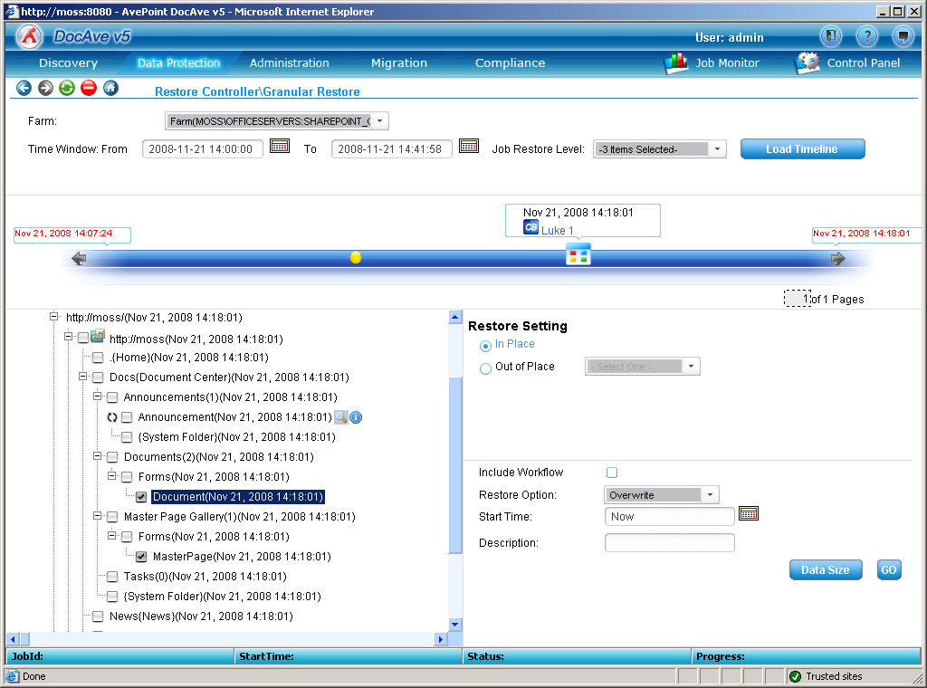
Click Go then click okay to the override

Backup of Platform
Allows for full backup of the MOSS farm including the Hive MOSS (12 folder and third party bin\GAC objects), IIS Settings and content
Select Data Protection – Custom Backup Builder – Platform Backup
In the left hand windows select Agent Host
Select Server name

Select content in the left hand pane
Setup the middle pane Data Manager
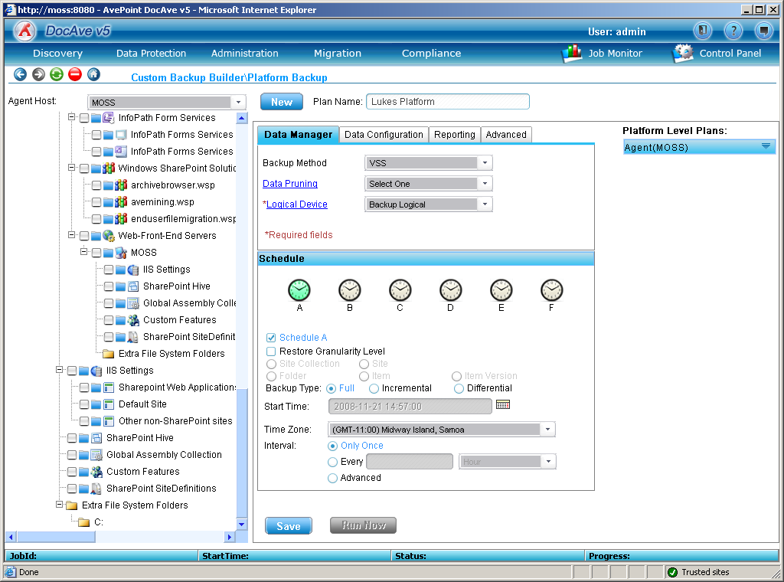
Click Save then Run now

Restore of Platform
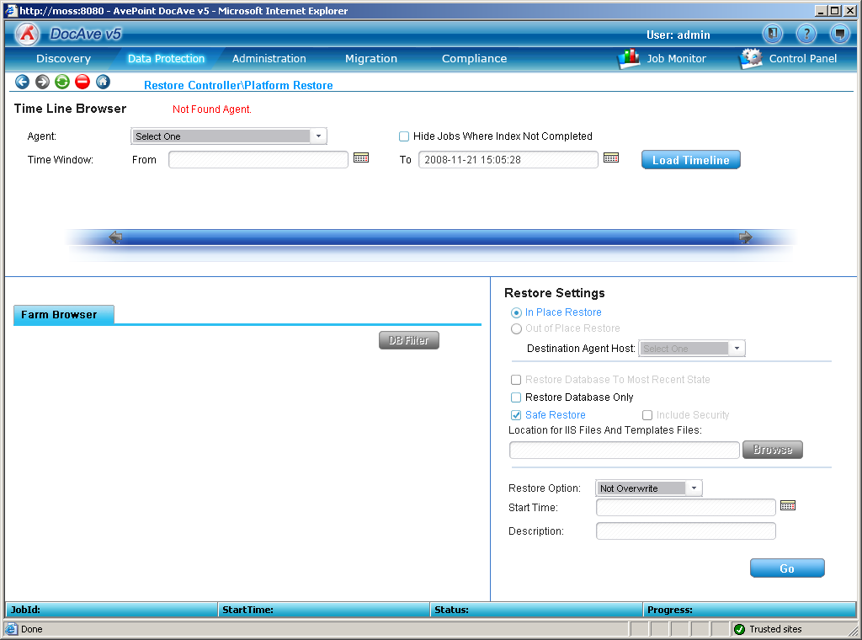

Backup Templates
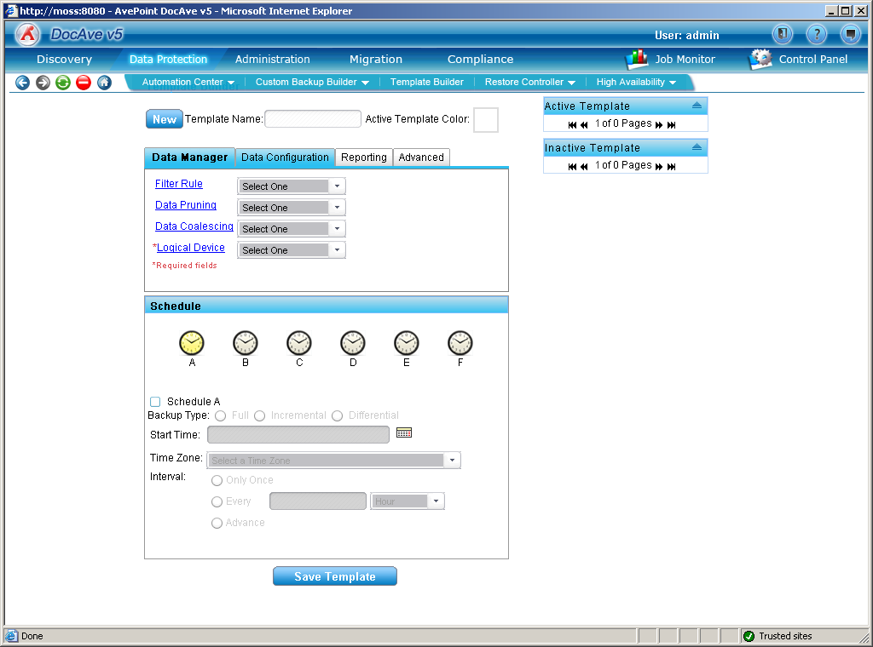

Automation Backups
Data Protection -> Automation Center -> Settings
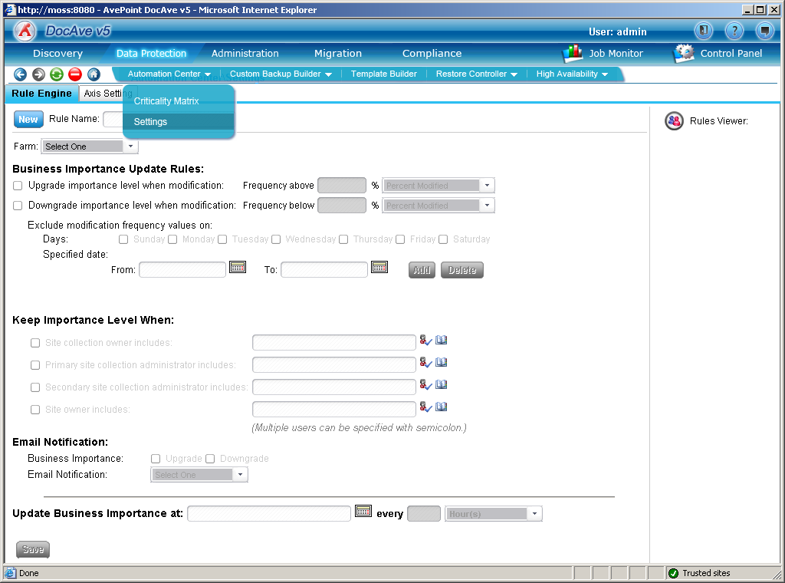
Enter Details as required
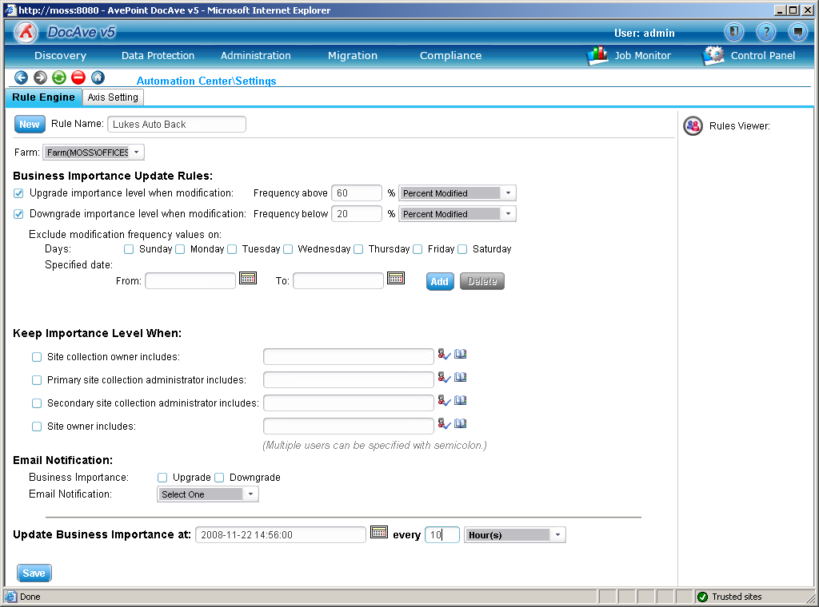
Click Save

High Availability
Option or either Log Shipping and SQL Mirroring
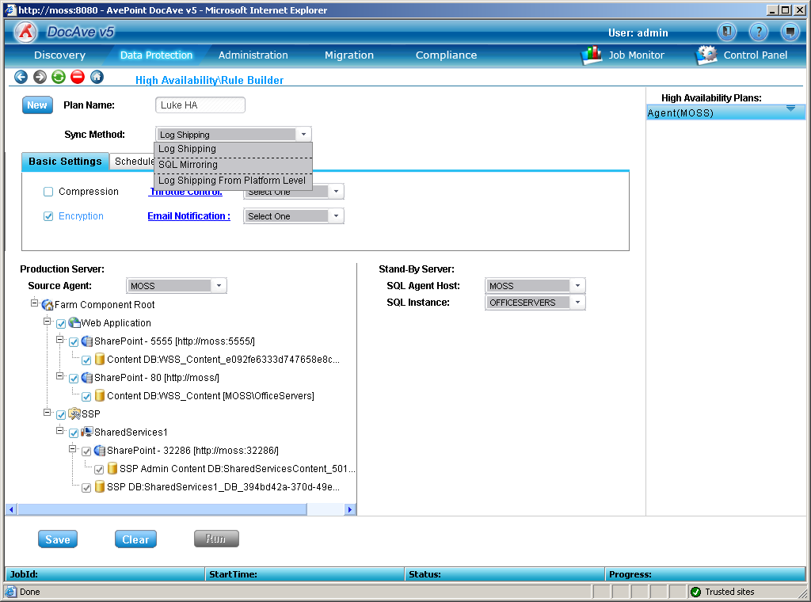

Job Monitor

