AvePoint DocAve 5
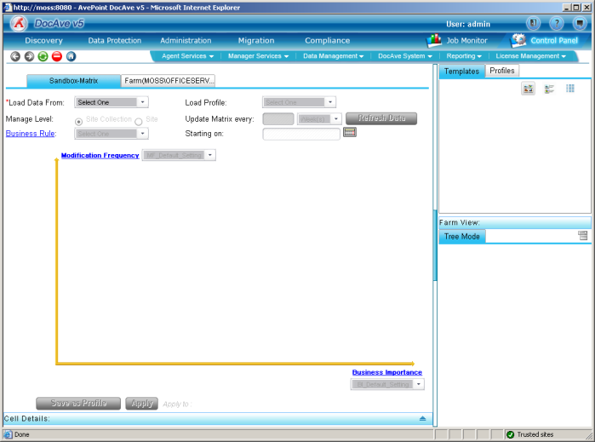

AvePoint DocAve provides a Backup and Archiving tool for SharePoint, Handy features such as stubbing large files out to a filing system and keeping the metadata in SharePoint (SQL) , language conversion in English, German and Japanese, replicated SharePoint Farms, alert plug-ins for MOM and SCOM are amongst some of the features DocAve provides and intelligent Backups.

DocAve Agents are required to be installed on MOSS servers and SQL Servers (if cluster both nodes)

DocAve 5 offers the following functions:

Discovery (free tool)
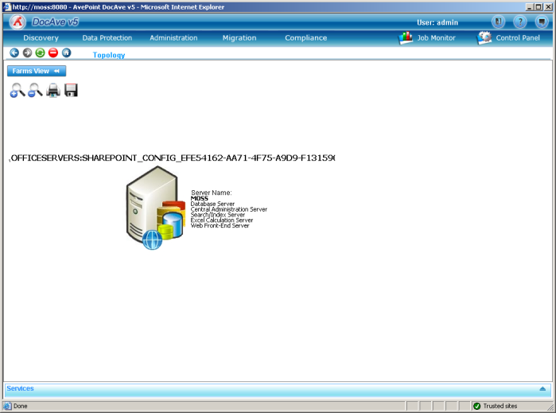
- Scan’s SharePoint Servers and discovers sites and site collections configured.
- Only works on servers where the agent is installed

Administration
- One place to change Central Admin Options
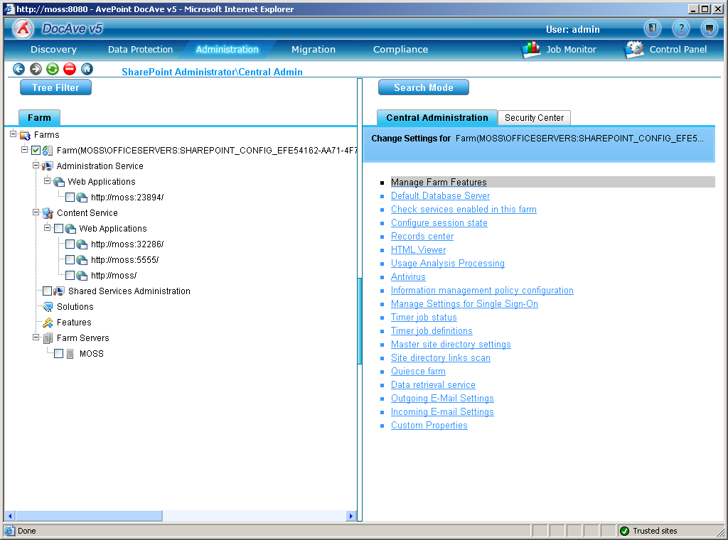
- Execute out-of-the-box STSADM Command (no custom commands hopefully changing soon), can also schedule STSADM commands
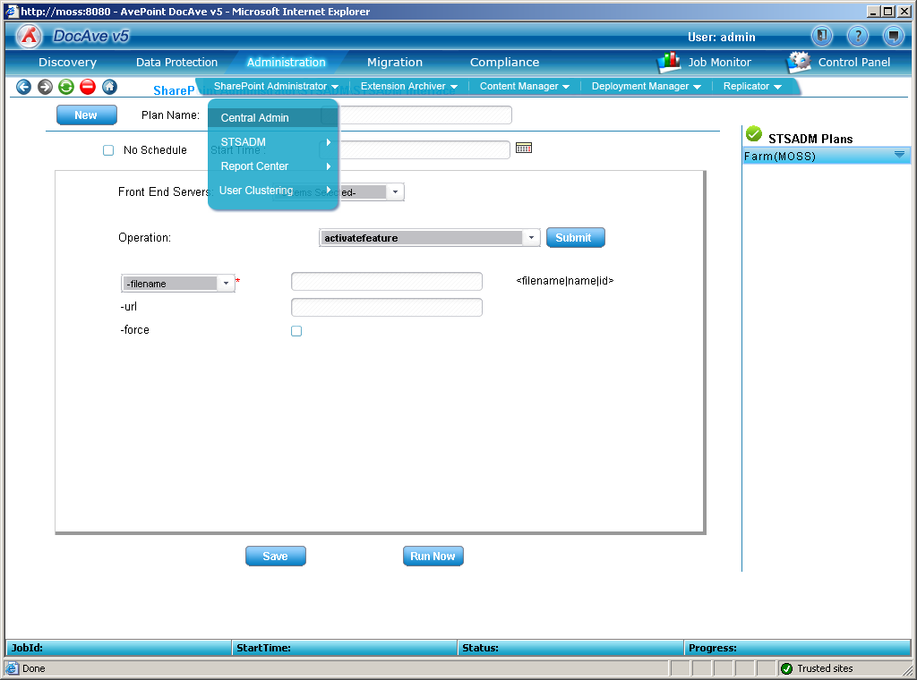
- Batch Updates
- Lock down security and test that the security is working
- Replication of the site (Bit Level data transfer).
  - Can be one-way or two-way
  - Conflict management
  - Traffic monitor
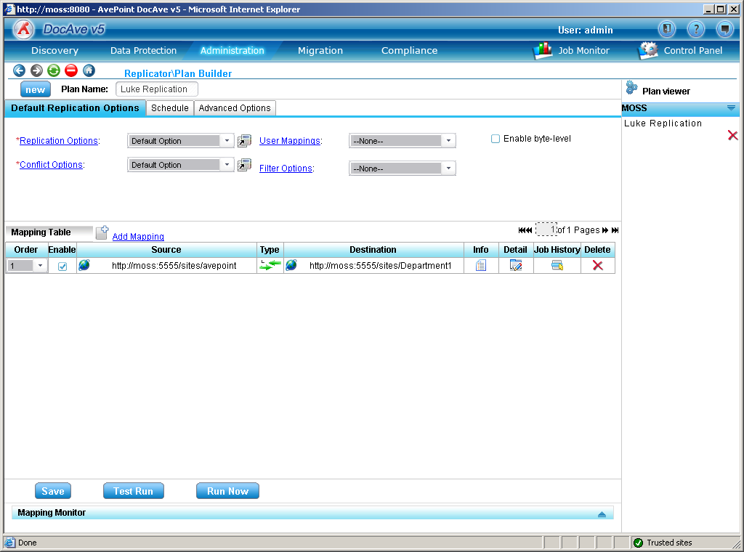
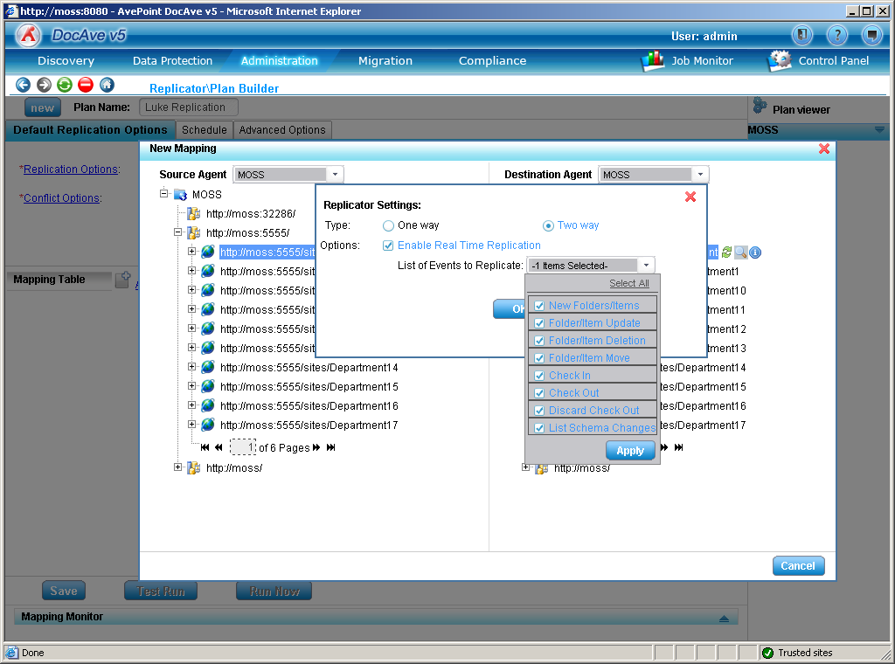
- Web part deployment
- Archive to hard drive, define time and the type of content
- Deployment manager, will deploy site structure, IIS settings, GAC objects, filing system it will NOT Deploy content

Compliance
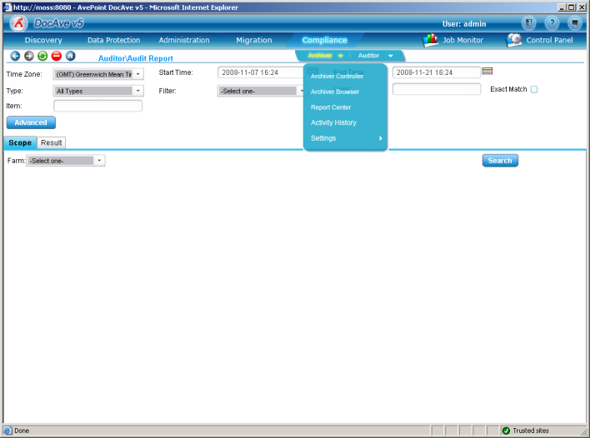
- Compliance Archiver
  - Retention policies
- Auditor
  - Find out what people have been adding\changing\deleting
  - Audit Searches
  - Track Usage

Migration
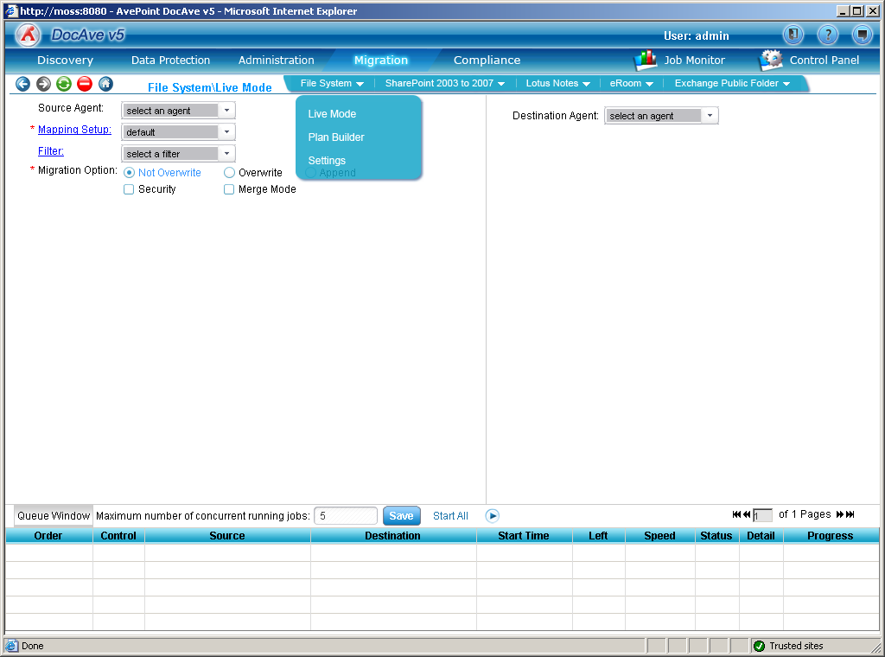
Built-in ability to:
- Migrate SharePoint 2003 and 2007 sites
- Migrate from a Filing System (UNC)
- Migrate from Lotus Notes
- Migrate from EMC Documentum eRoom
- Migrate from Exchange Public Folder

Data Protection
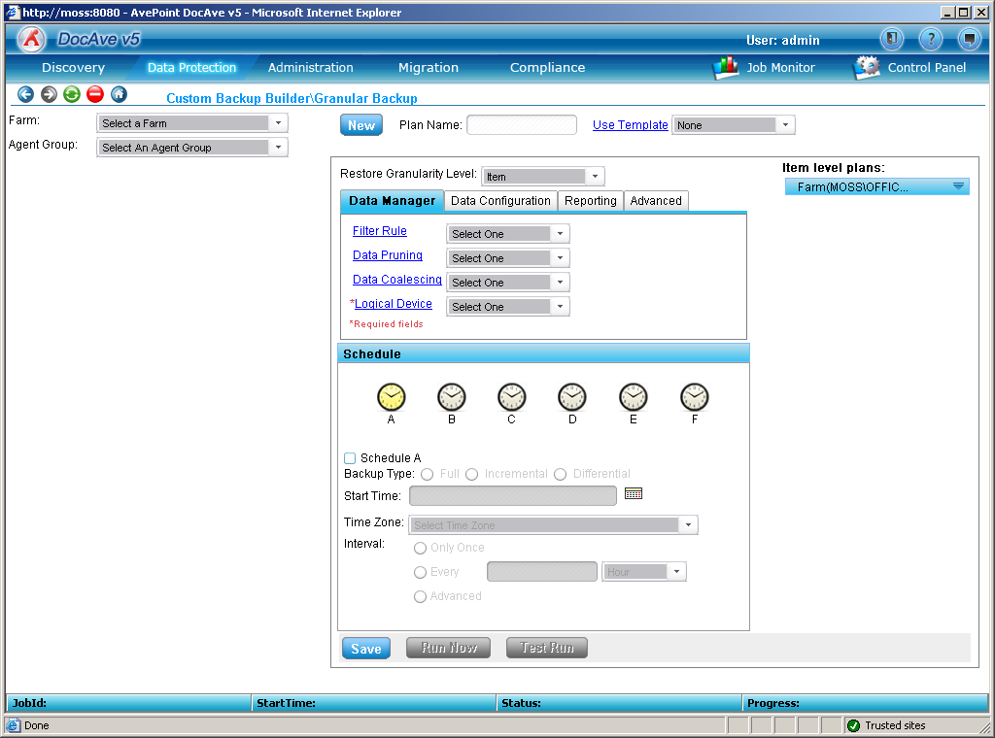
- Total Farm Backup with granular item-level full fidelity recovery which means down to the item restore of documents, Items in a list and SharePoint site content (aspx’s, security etc..) – based on SQL tlog injection
- High-availability is based on SQL Log-shipping and Database mirroring, AvePoint will automatically create the SQL policy.
- Intelligent backup policies can be created so that important data will always get backed up for example a site that might only get 10 connections could be defined to use a weekly backup if the site ends up getting 10000 connections then the site will automatically be added to the daily backup

Further feature details:

Backup ability
- Multiple backup types: Full, Differential and Incremental
- Multiple backup storage devices (improved availability)
- Pruning of Backup jobs (remove backup history and backup job history)
- Coalescing of backup jobs, this function allows incremental backups to be merged into the Full backup – improves disk space.
- Backup Data Import – allows you to take a remote off-site backup and then restore back to SharePoint
- Exclude file formats and folder names, can choose to exclude none business critical file extensions for example *.mp3
- Include file formats and folder names, can choose specific file types for example the business only requires *.pdf and *.doc
- Encryption of data can be 128bit
- Secure data with passwords
- Compression can be enabled on the backup with a ratio of between 4:1 and 5:1
- Backup to Devices can be FTP, UNC, File, IBM Tivoli TSM and NetApp Snap manager for MOSS, Brocade for MOSS and another leading 2 vendors coming soon.
- AvePoint backup speed is 60GB/hr or with NetApp’s hardware backup time can be increased to 2.3TB/hr (VTL300) to 8.2TB/hr (VTL1400).
- VSS or VCI support, VSS should be used as it is quicker but it is only supported in SQL 2005 and above
- Able to Restore from SQL Backups

Note: Incremental backups work as follows:
- If you configure the backups to backups documents the incremental size will be document size + change size + full backup (i.e.( 100Mb + 5Mb) = 105Mb + 1000MB = 1105Mb)
- If you configure the backups just to be the size collection changing just one document will be site collection size + doc change + full backup (i.e. (1000Mb + 5) = 1005Mb + 1000Mb = 2005Mb)

Archive
- Data stored to disk and coming soon back to TSM
- Can define Archive Retention Policy to hard delete archive data after x amount of days, weeks, months, years.
- Secure data with passwords
- Stubs the data
- Caching size formula 1.5 time

Services which Ave Point Install:
- Media Service (controls media pools)
- Web service (GUI)
- Control (DB)
- Media (backups\file storage)
- Search (security and content)
- Audit
- Communication (agent for communicating to SharePoint)

